Silhouette metric for img015001.jpg is: 0.9840689247367167

Davies Bouldin metric for img015001.jpg is: 0.019999287880343802

Calinski Harabasz metric for img015001.jpg is: 1306750.834132018

ID 0: (1543, 653)

ID 1: (135, 608)

ID 2: (1677, 736)

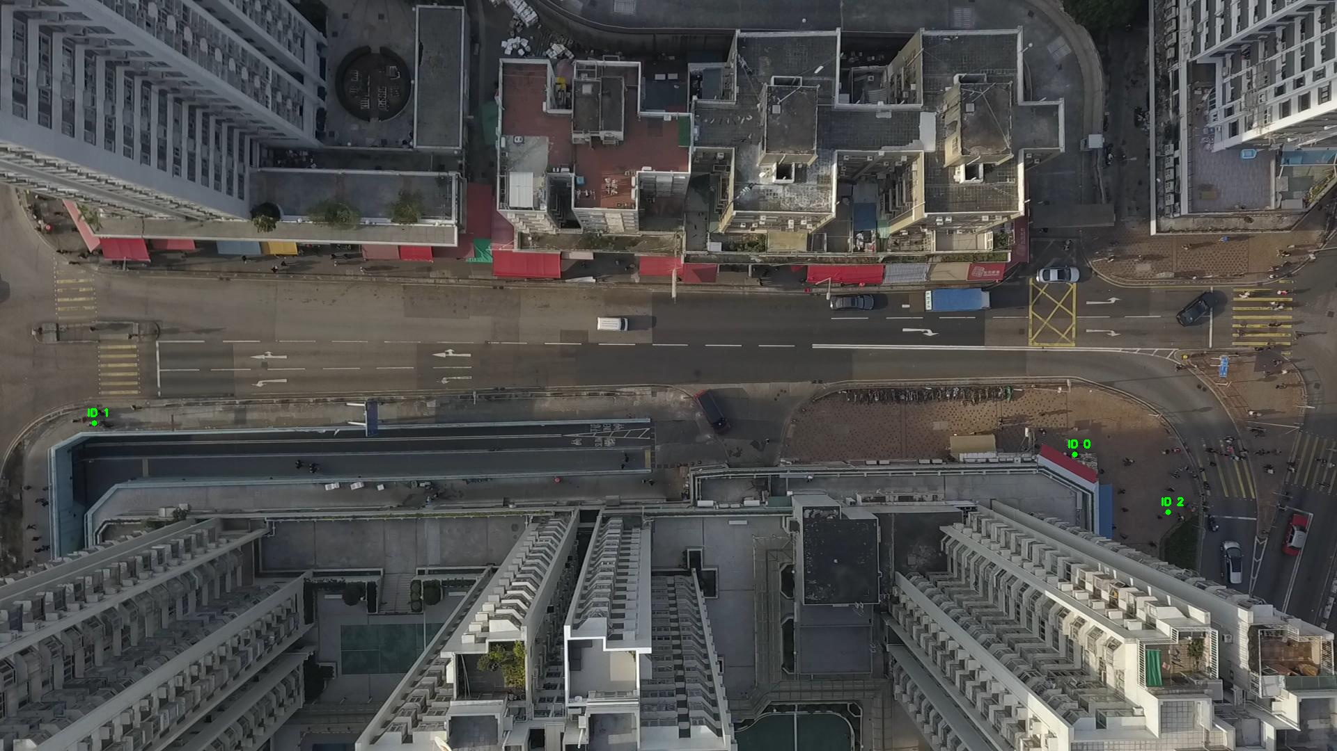

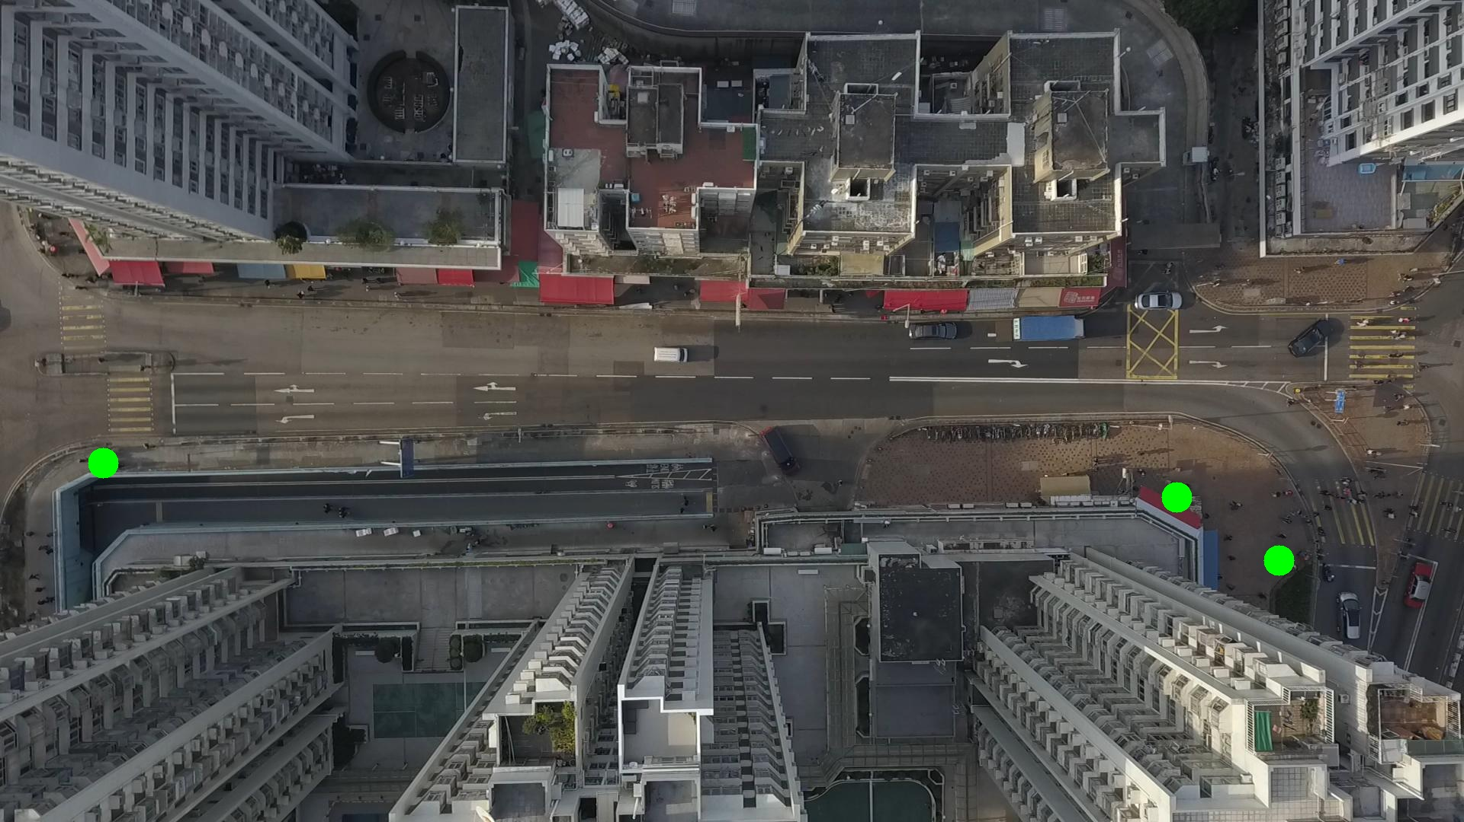

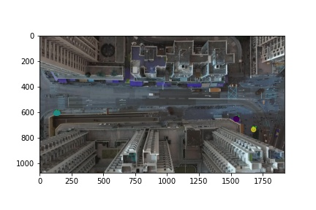

Silhouette metric for img015002.jpg is: 0.9869096599345946

Davies Bouldin metric for img015002.jpg is: 0.02462976384978885

Calinski Harabasz metric for img015002.jpg is: 2078929.677131519

ID 0: (1543, 653)

ID 1: (133, 608)

ID 2: (1748, 652)

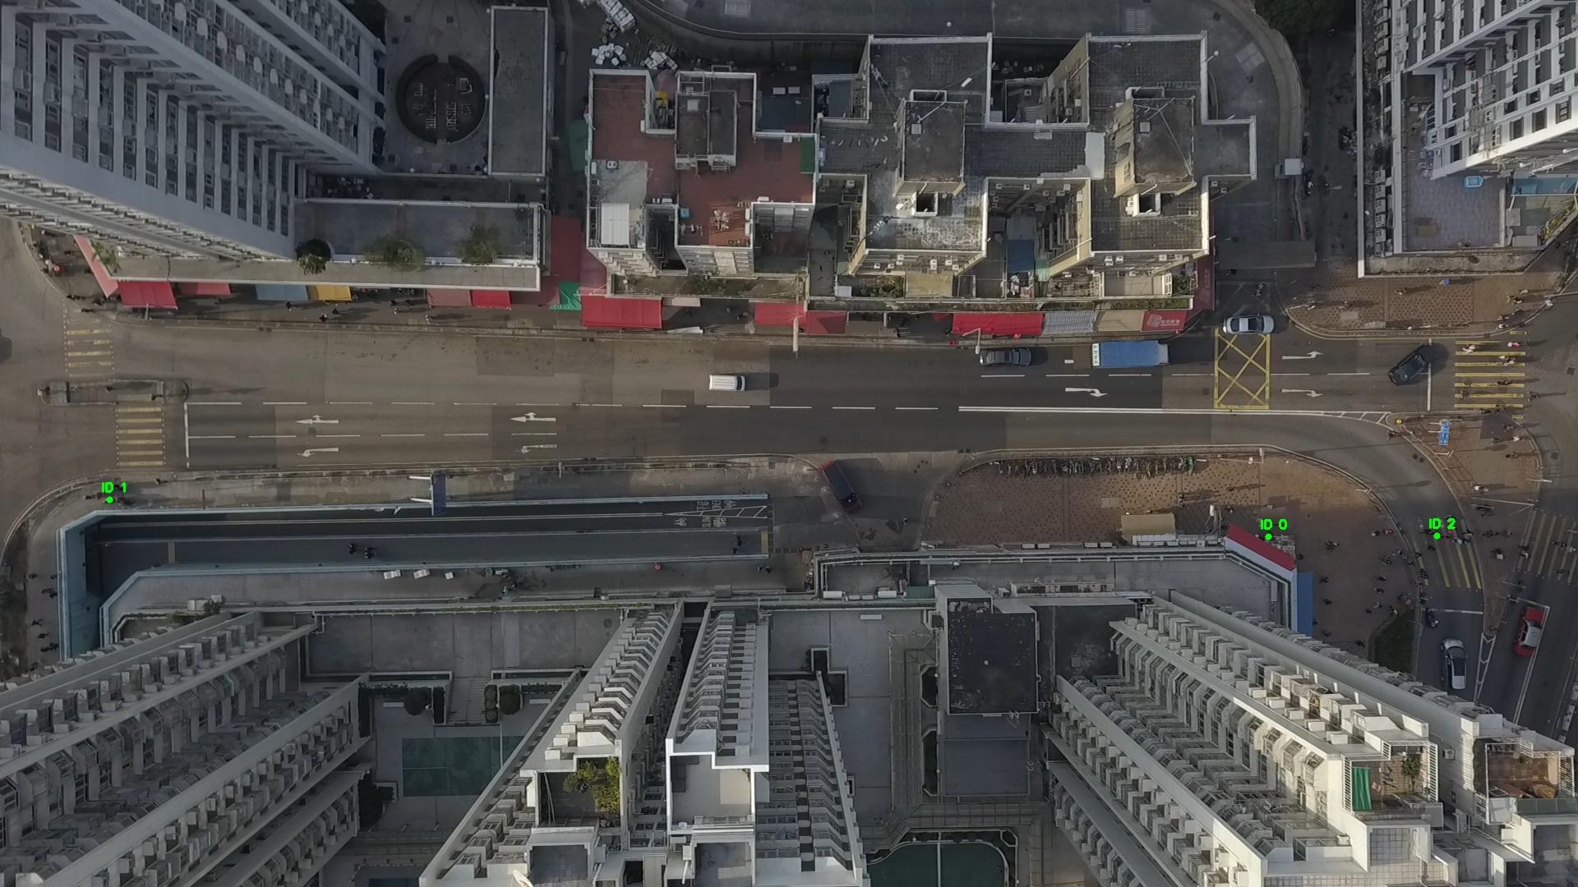

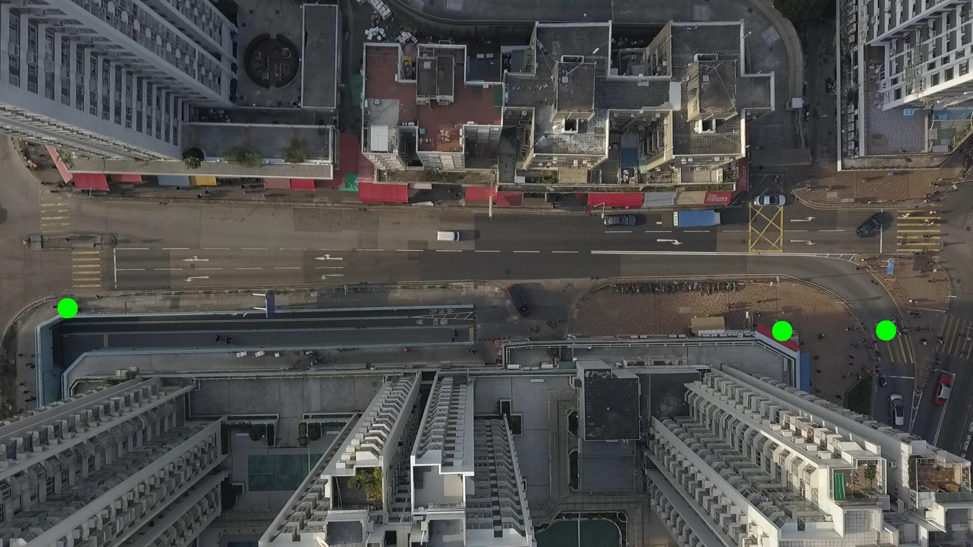

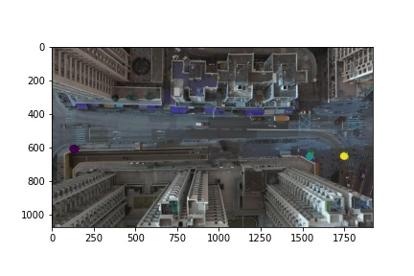

Silhouette metric for img015003.jpg is: 0.9749248856652682

Davies Bouldin metric for img015003.jpg is: 0.02143977420581182

Calinski Harabasz metric for img015003.jpg is: 2417103.645750708

ID 0: (1543, 652)

ID 1: (138, 608)

ID 2: (1769, 657)

ID 3: (1677, 736)

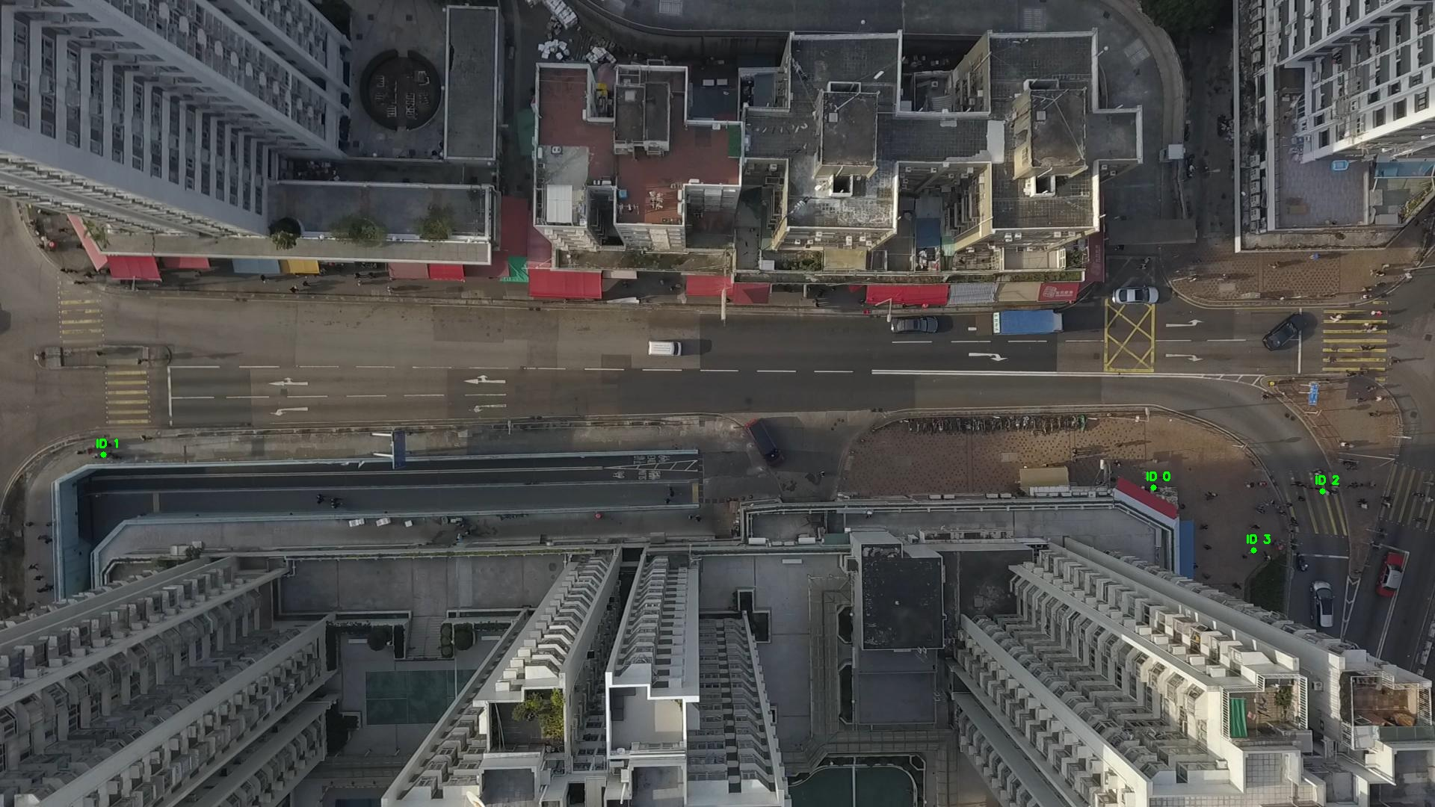

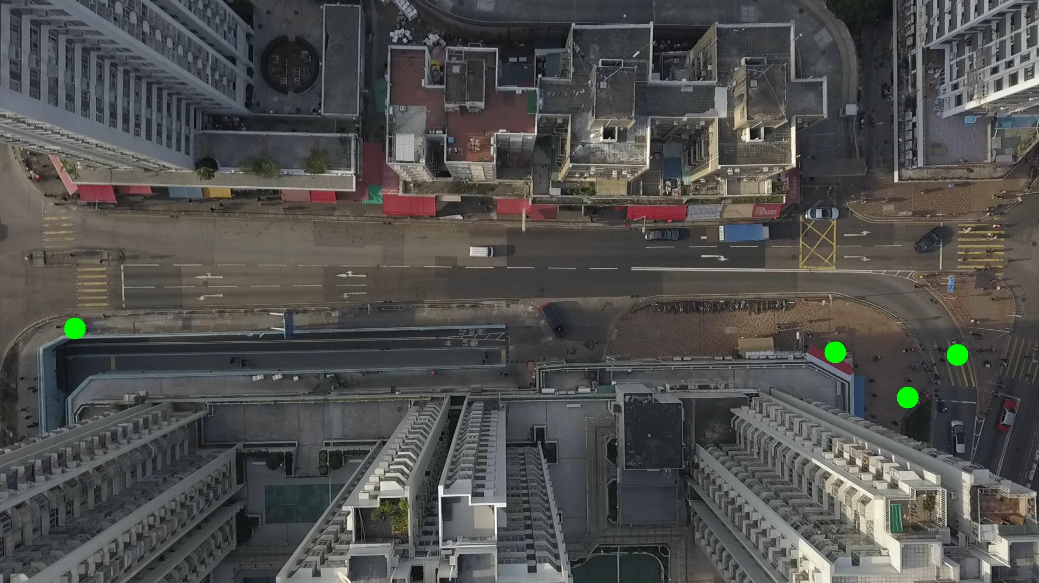

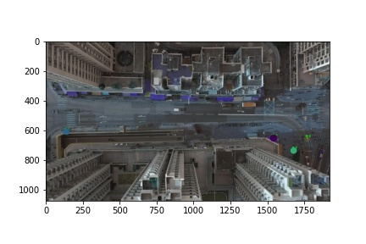

Silhouette metric for img015004.jpg is: 0.9975136921506035

Davies Bouldin metric for img015004.jpg is: 0.0033643952430236616

Calinski Harabasz metric for img015004.jpg is: 4594034.734868993

ID 0: (1544, 653)

ID 1: (138, 608)

ID 2: (1769, 657)

ID 3: (1677, 736)

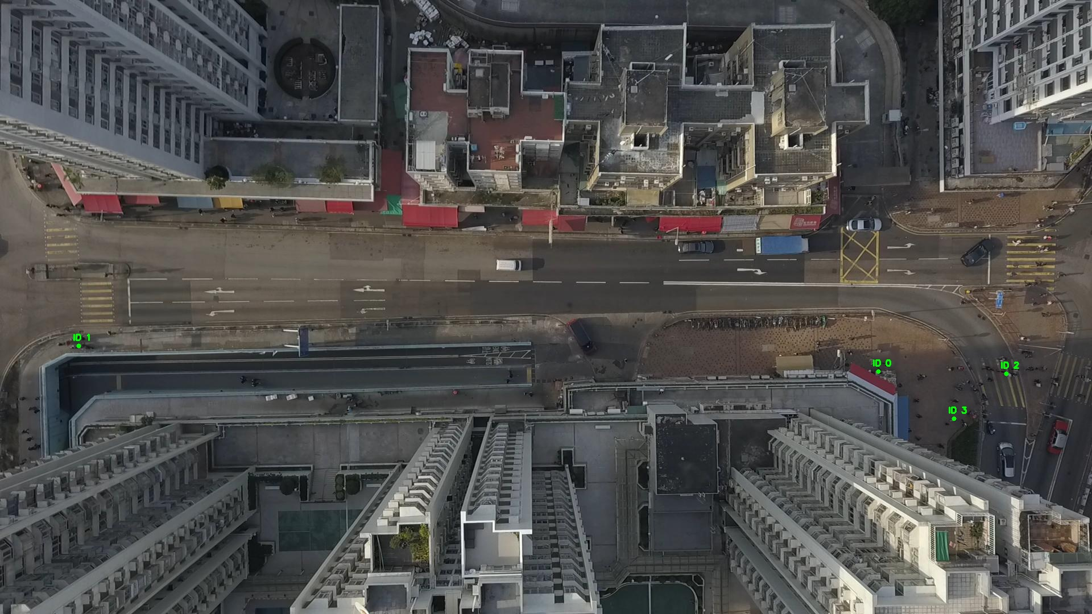

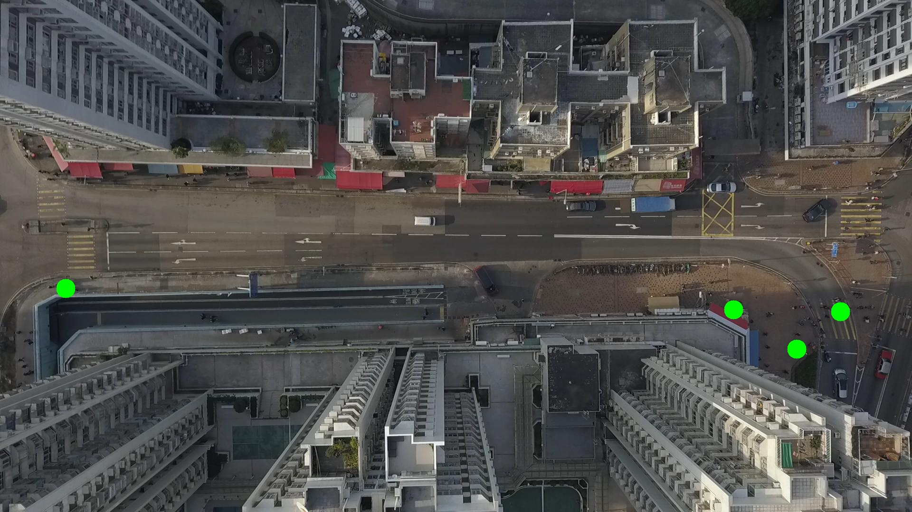

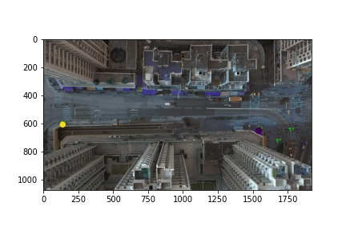

Silhouette metric for img015005.jpg is: 0.9970179859082143

Davies Bouldin metric for img015005.jpg is: 0.006210885577198835

Calinski Harabasz metric for img015005.jpg is: 999555.5526432139

ID 0: (1544, 652)

ID 1: (132, 609)

ID 2: (1769, 657)

ID 3: (1677, 736)

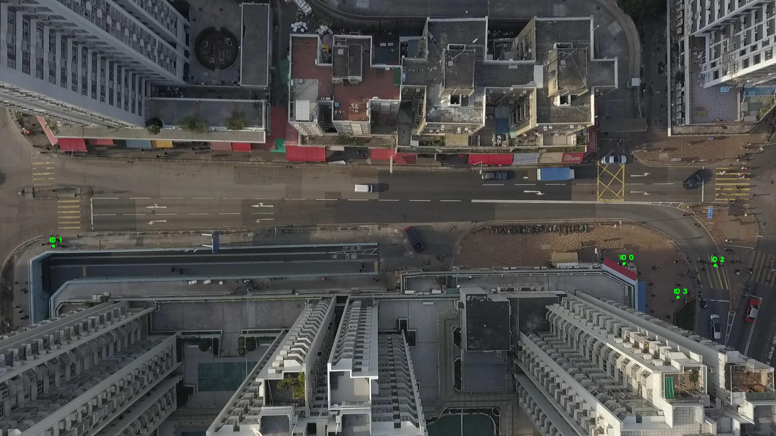

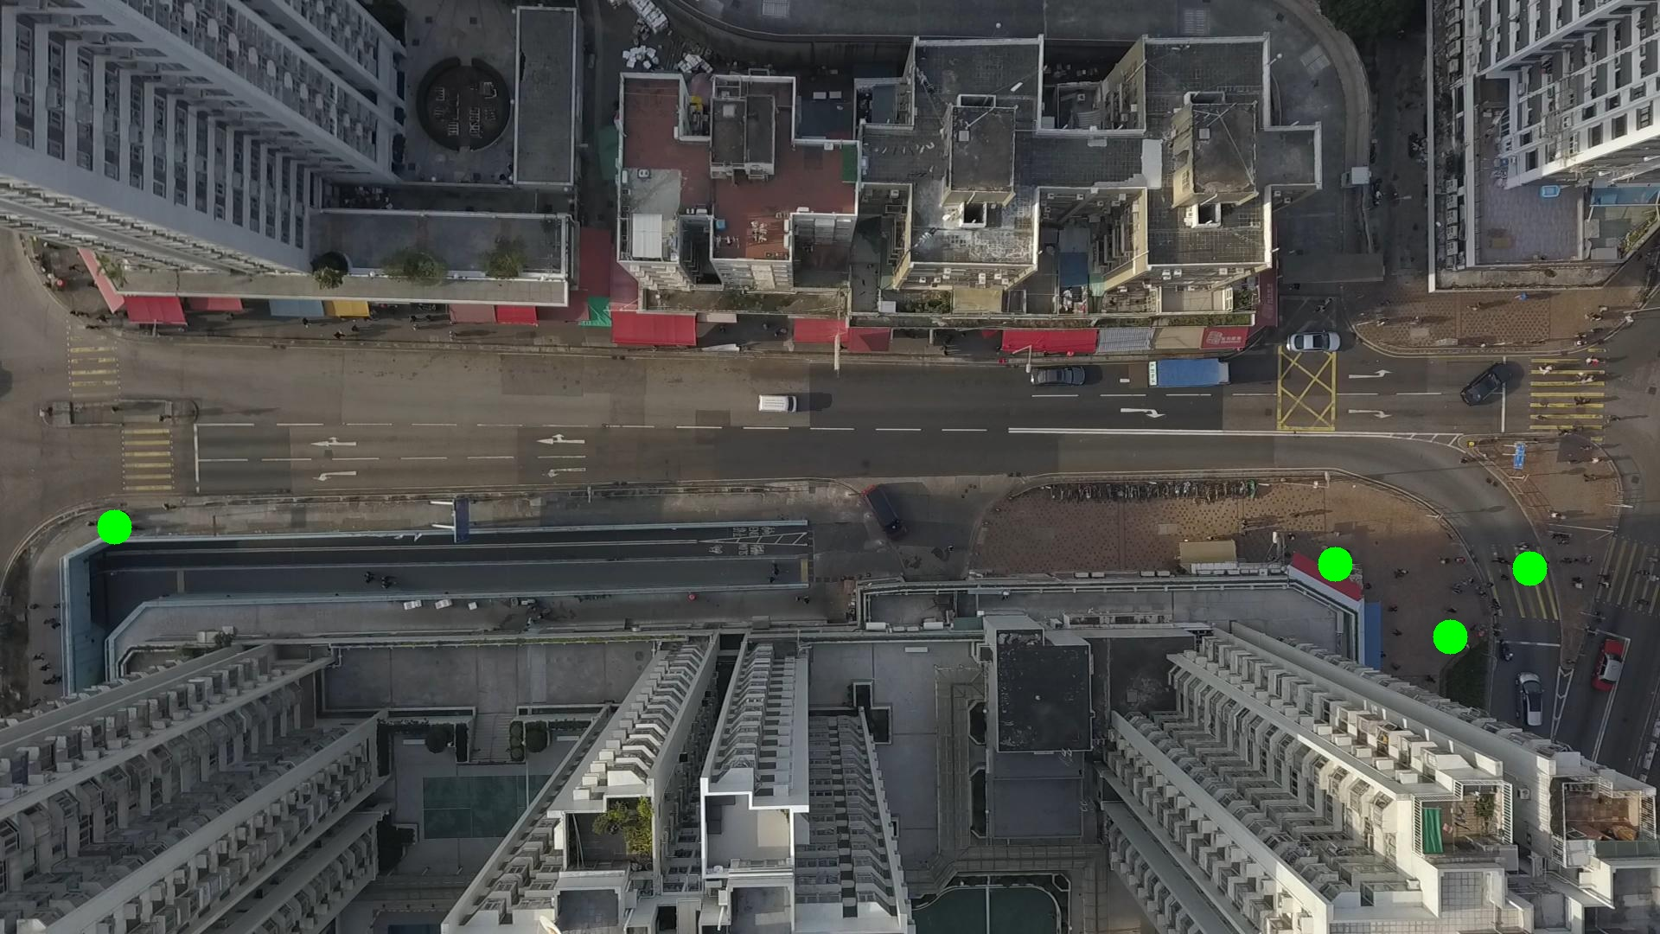

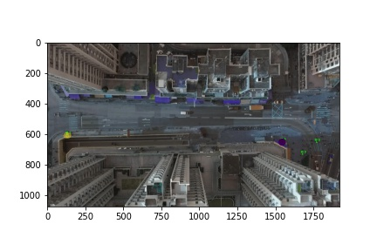

Silhouette metric for img015006.jpg is: 0.9793279329383007

Davies Bouldin metric for img015006.jpg is: 0.0245866325810299

Calinski Harabasz metric for img015006.jpg is: 1709611.731384163

ID 0: (1544, 653)

ID 1: (135, 608)

ID 2: (1769, 657)

ID 3: (1677, 736)

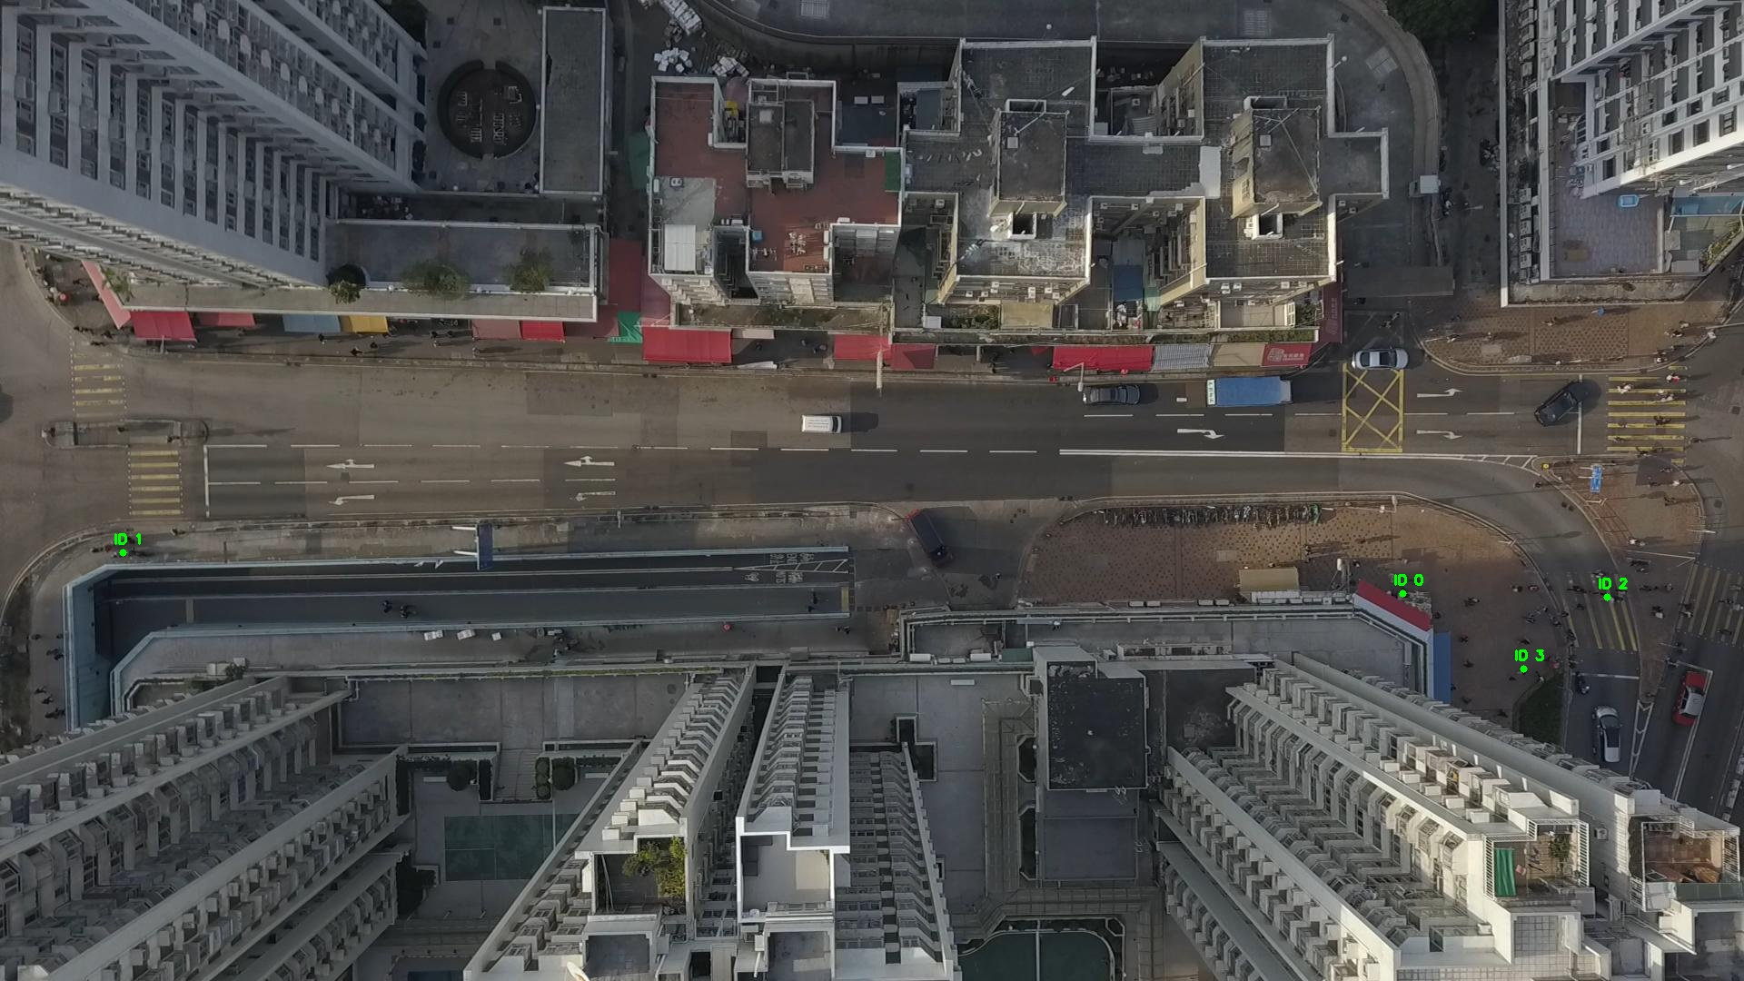

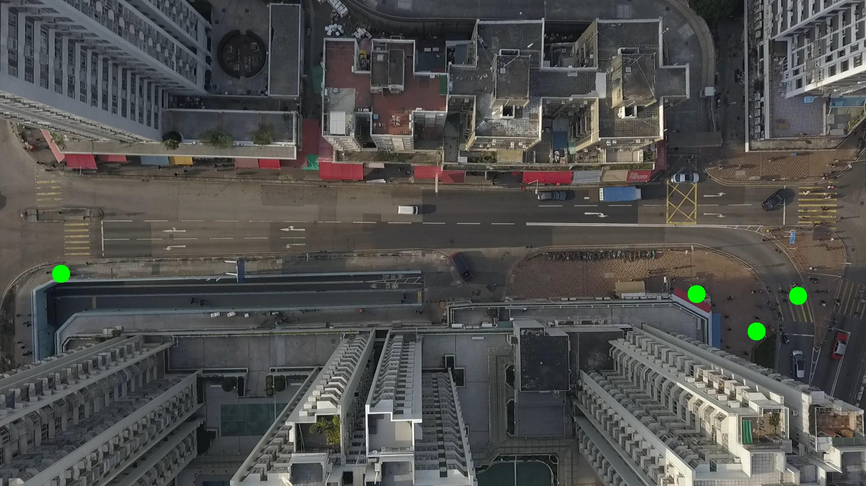

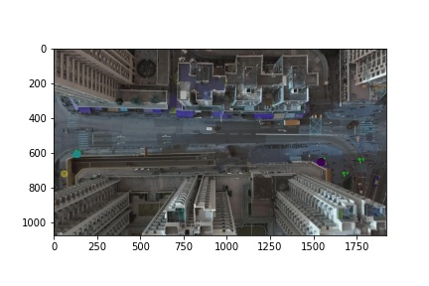

Silhouette metric for img015007.jpg is: 0.9971411184347619

Davies Bouldin metric for img015007.jpg is: 0.004088574795101264

Calinski Harabasz metric for img015007.jpg is: 2847947.0209108973

ID 0: (1544, 652)

ID 1: (135, 608)

ID 2: (1769, 657)

ID 3: (1677, 736)

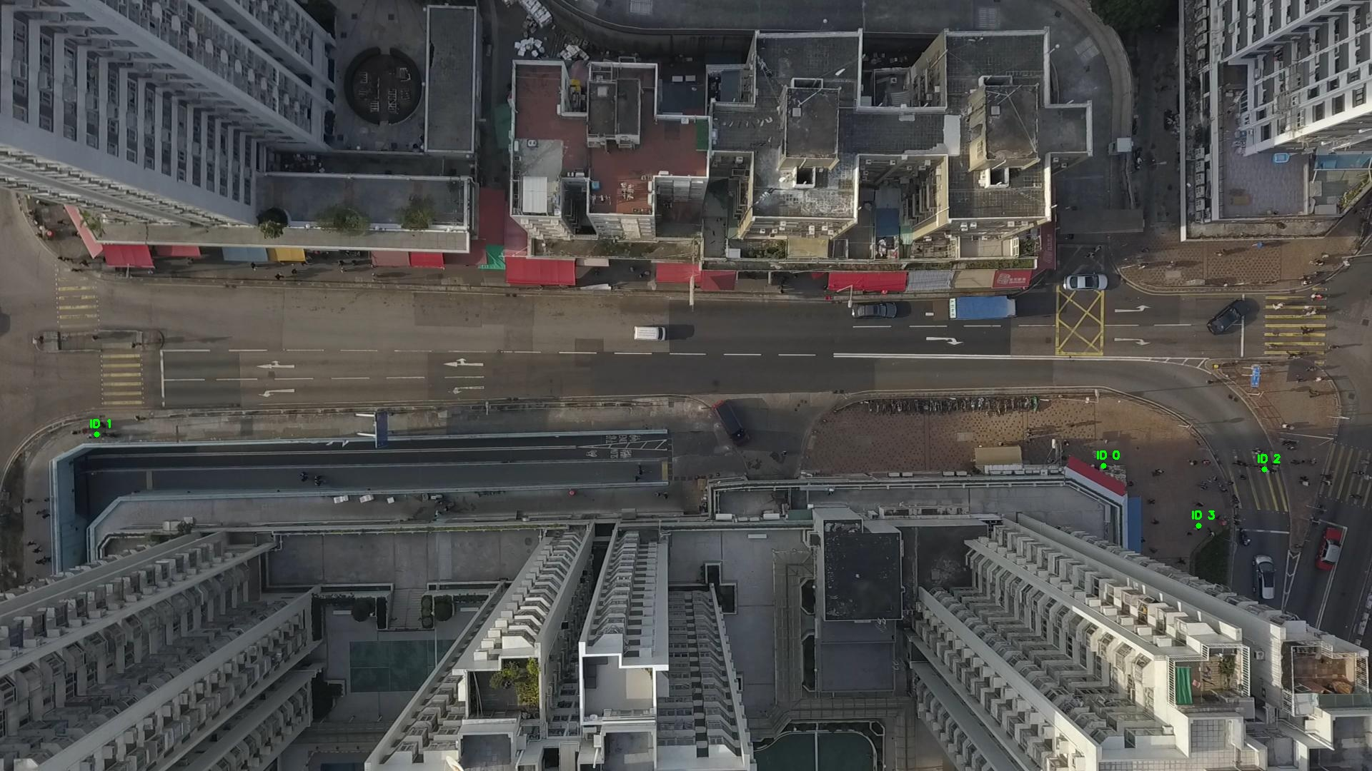

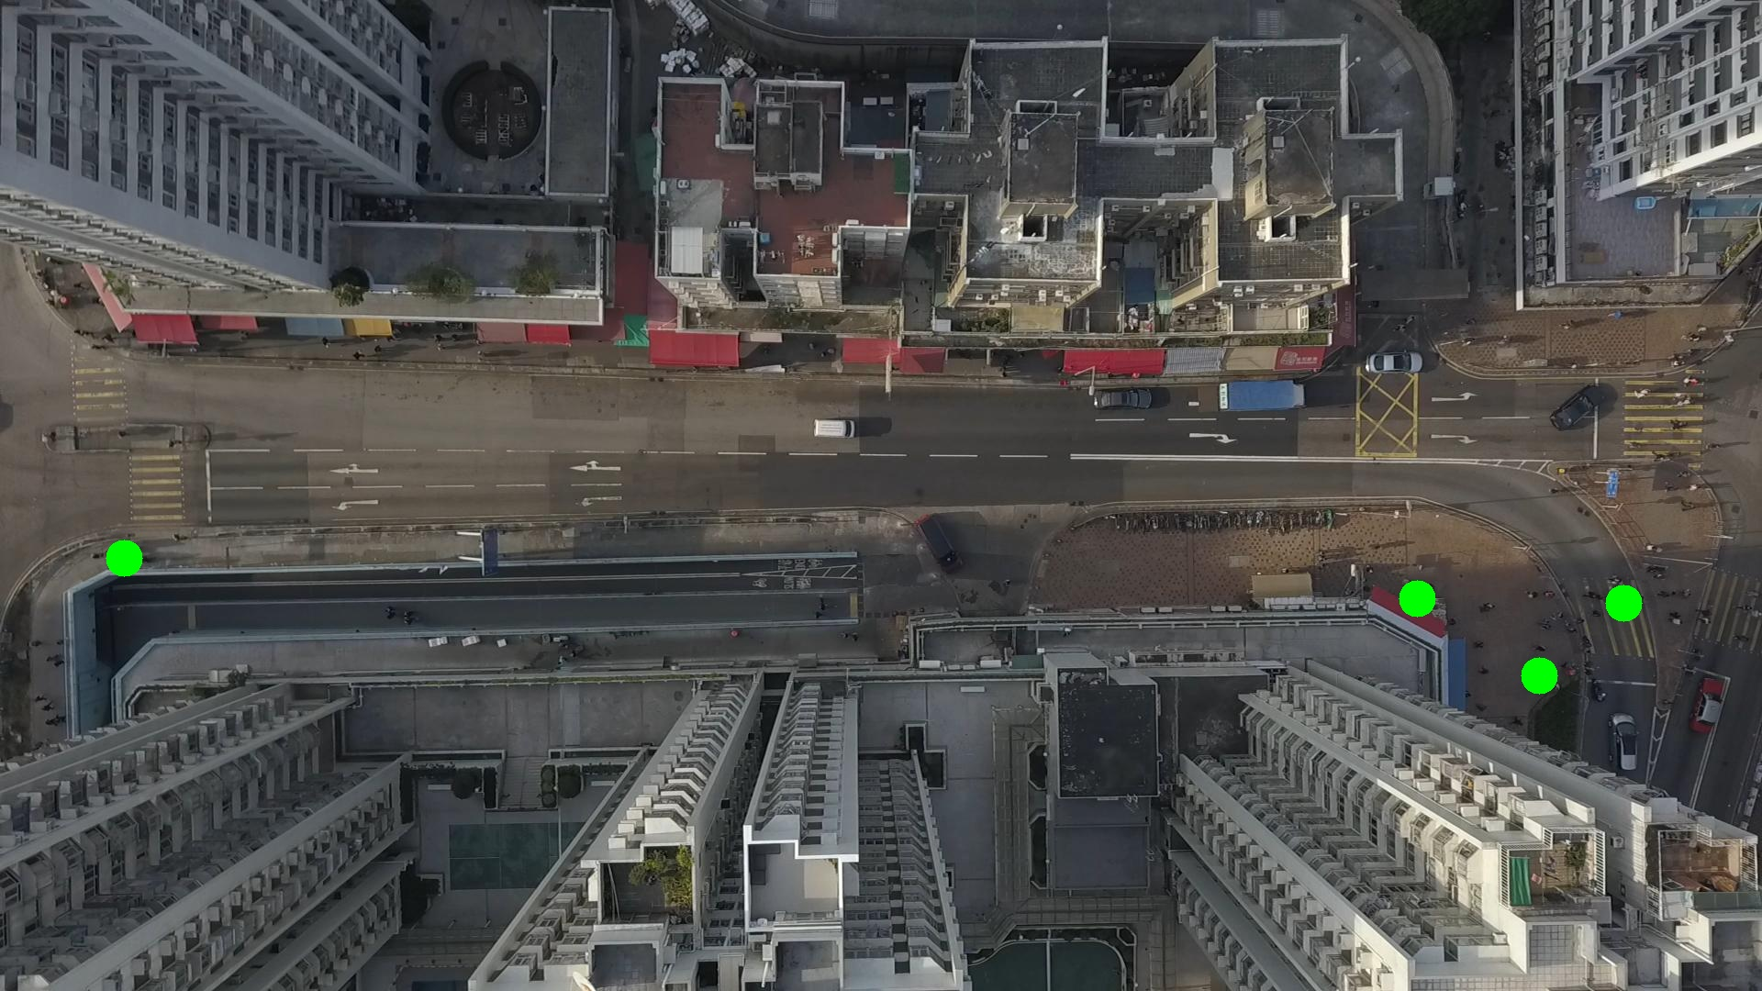

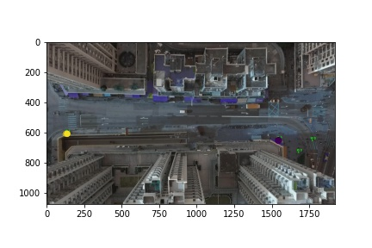

Silhouette metric for img015008.jpg is: 0.9975253858925233

Davies Bouldin metric for img015008.jpg is: 0.0032972421992396484

Calinski Harabasz metric for img015008.jpg is: 4082658.85743234

ID 0: (1543, 652)

ID 1: (136, 608)

ID 2: (1769, 657)

ID 3: (1677, 736)

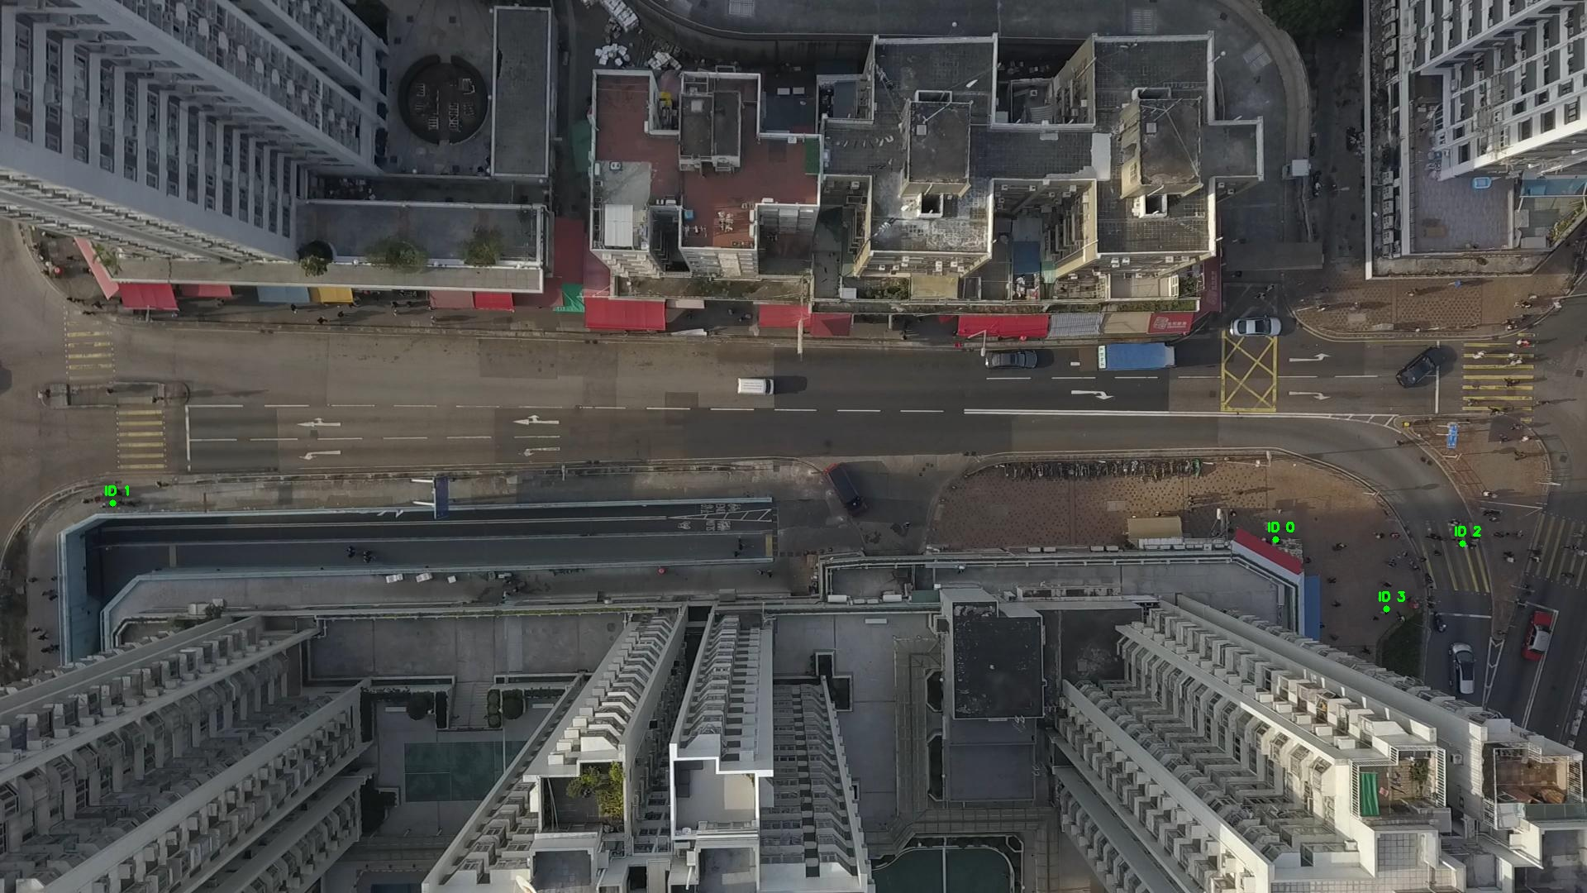

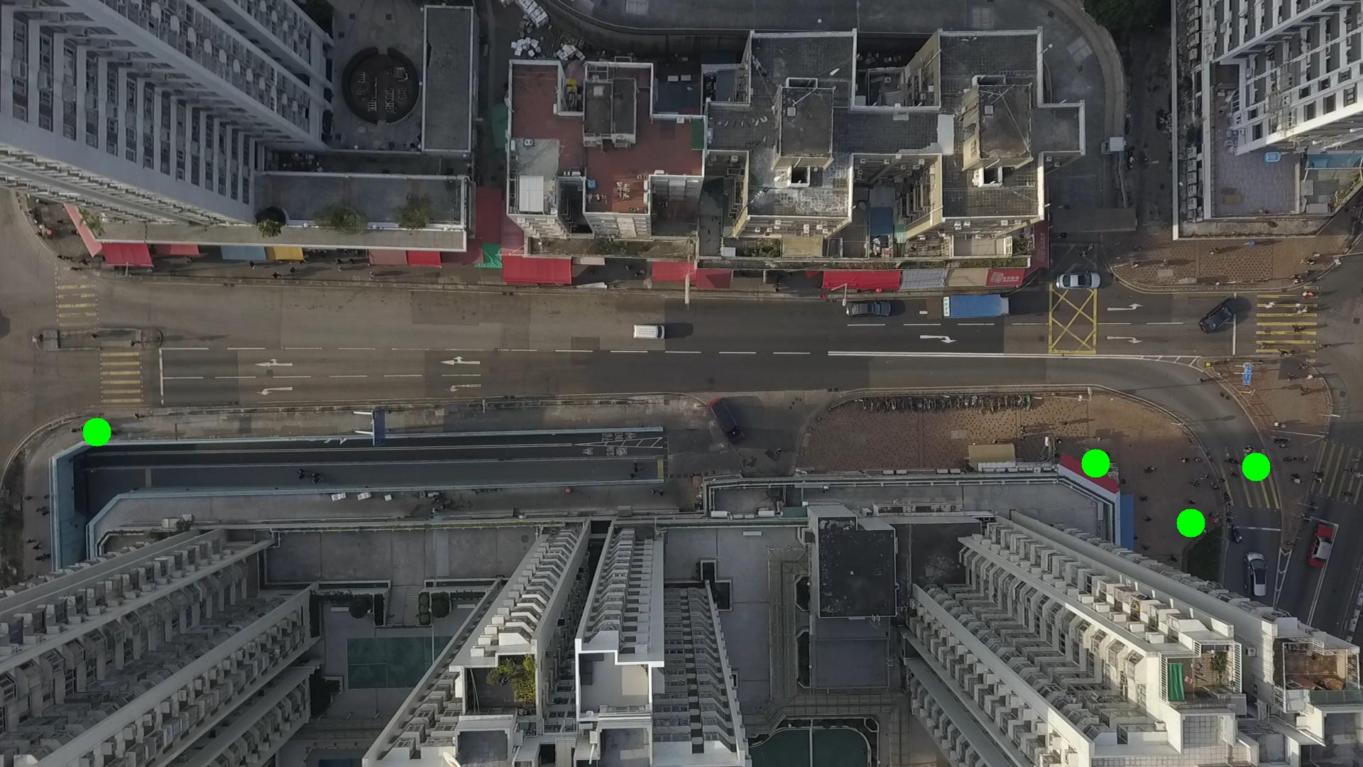

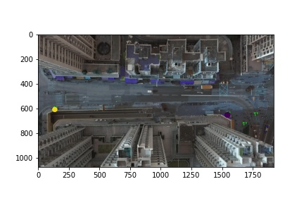

Silhouette metric for img015009.jpg is: 0.9814345454251734

Davies Bouldin metric for img015009.jpg is: 0.020618031091418715

Calinski Harabasz metric for img015009.jpg is: 31985.947305128702

ID 0: (1544, 652)

ID 1: (136, 608)

ID 2: (1738, 650)

ID 3: (1677, 736)

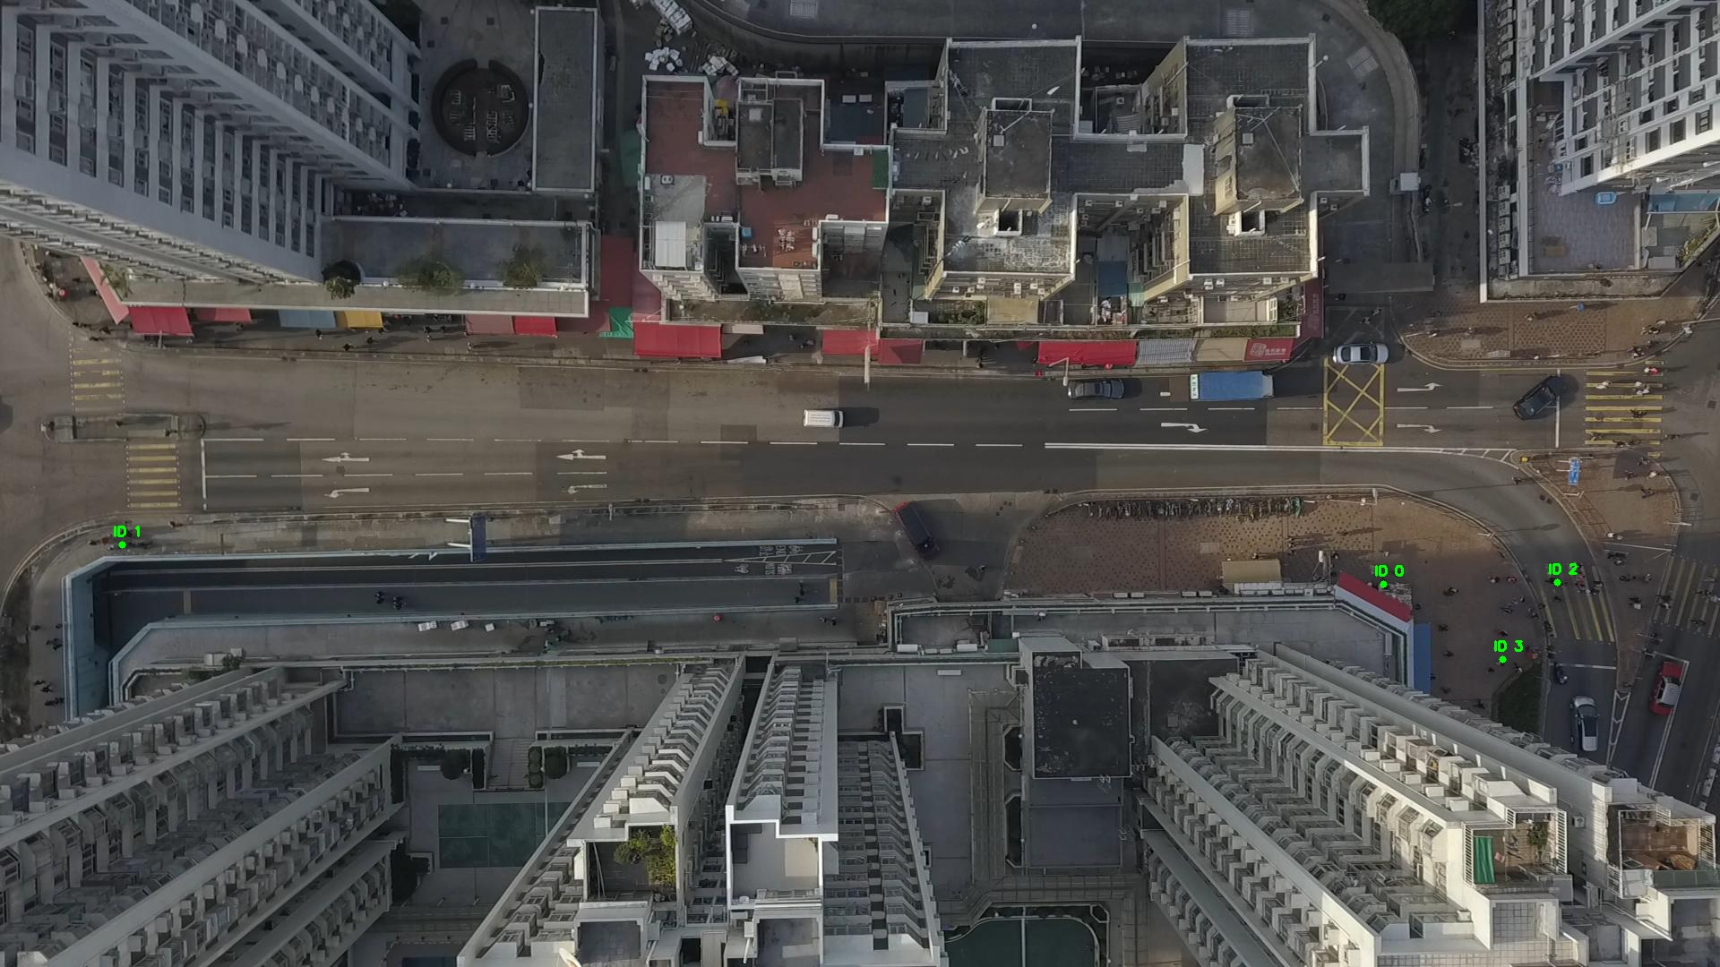

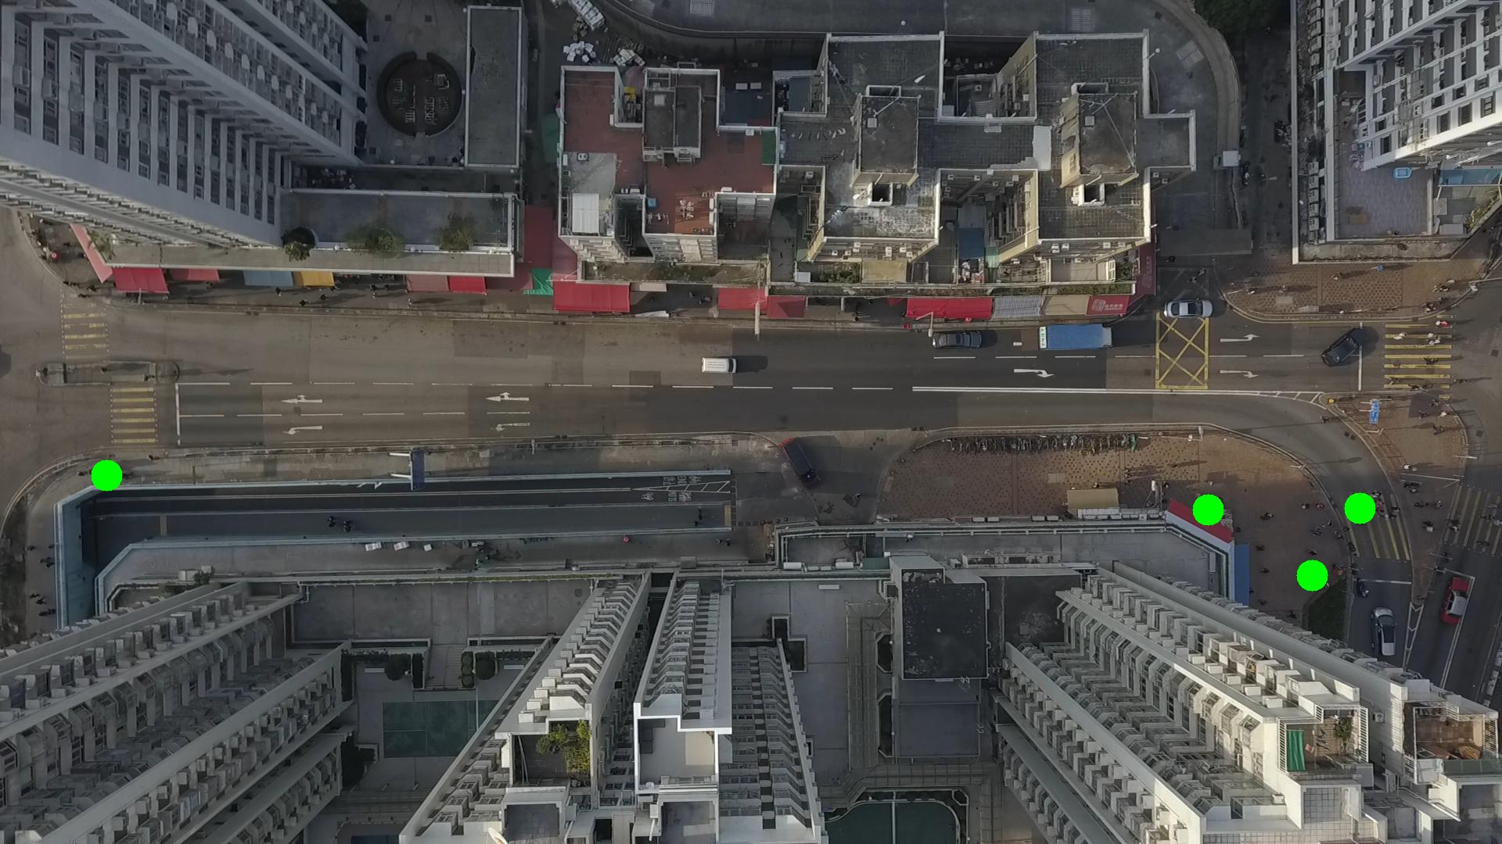

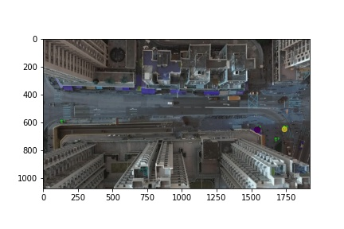

Metrics are not computable for img015010.jpg with bg_tresh: 0.75

ID 0: (1543, 653)

ID 1: (136, 608)

ID 2: (1738, 650)

ID 3: (1677, 736)

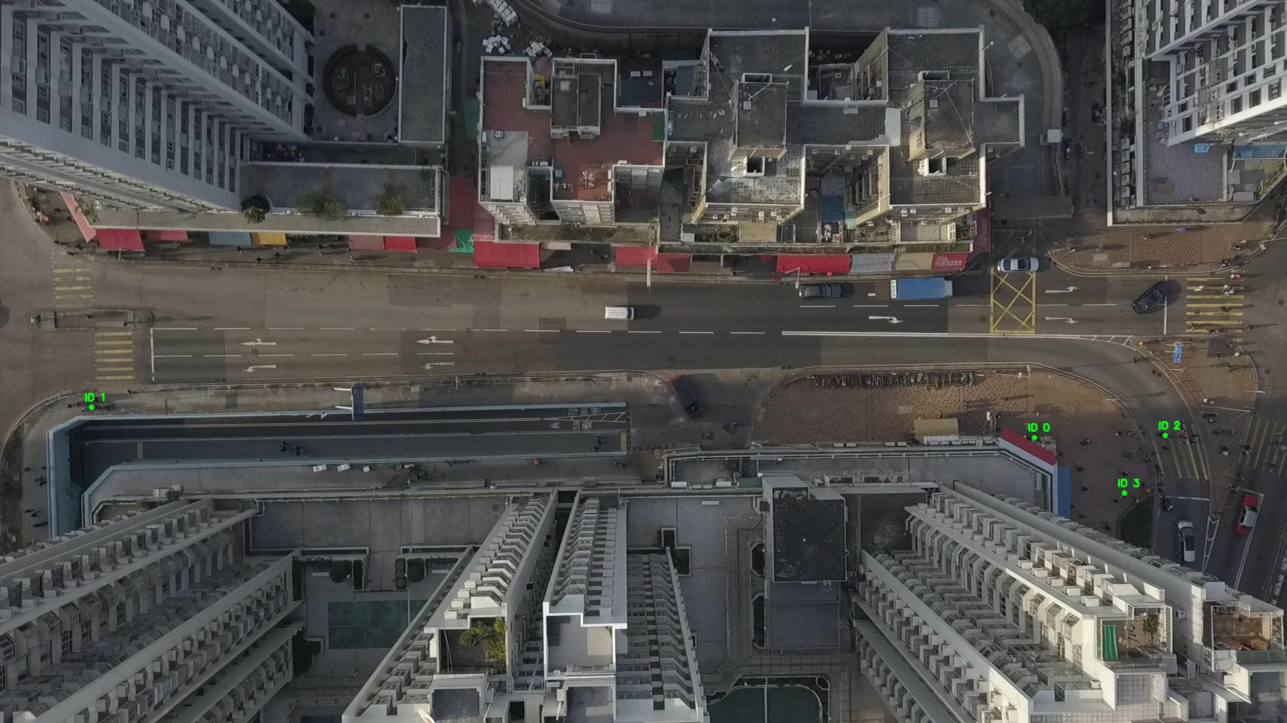

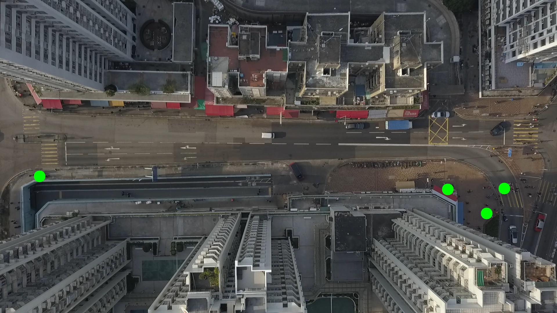

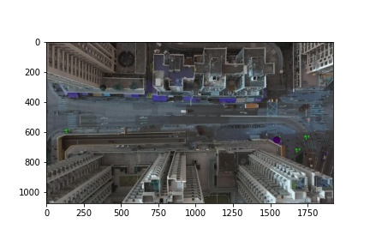

Metrics are not computable for img015011.jpg with bg_tresh: 0.75

ID 0: (1543, 653)

ID 1: (136, 608)

ID 2: (1738, 650)

ID 3: (1677, 736)

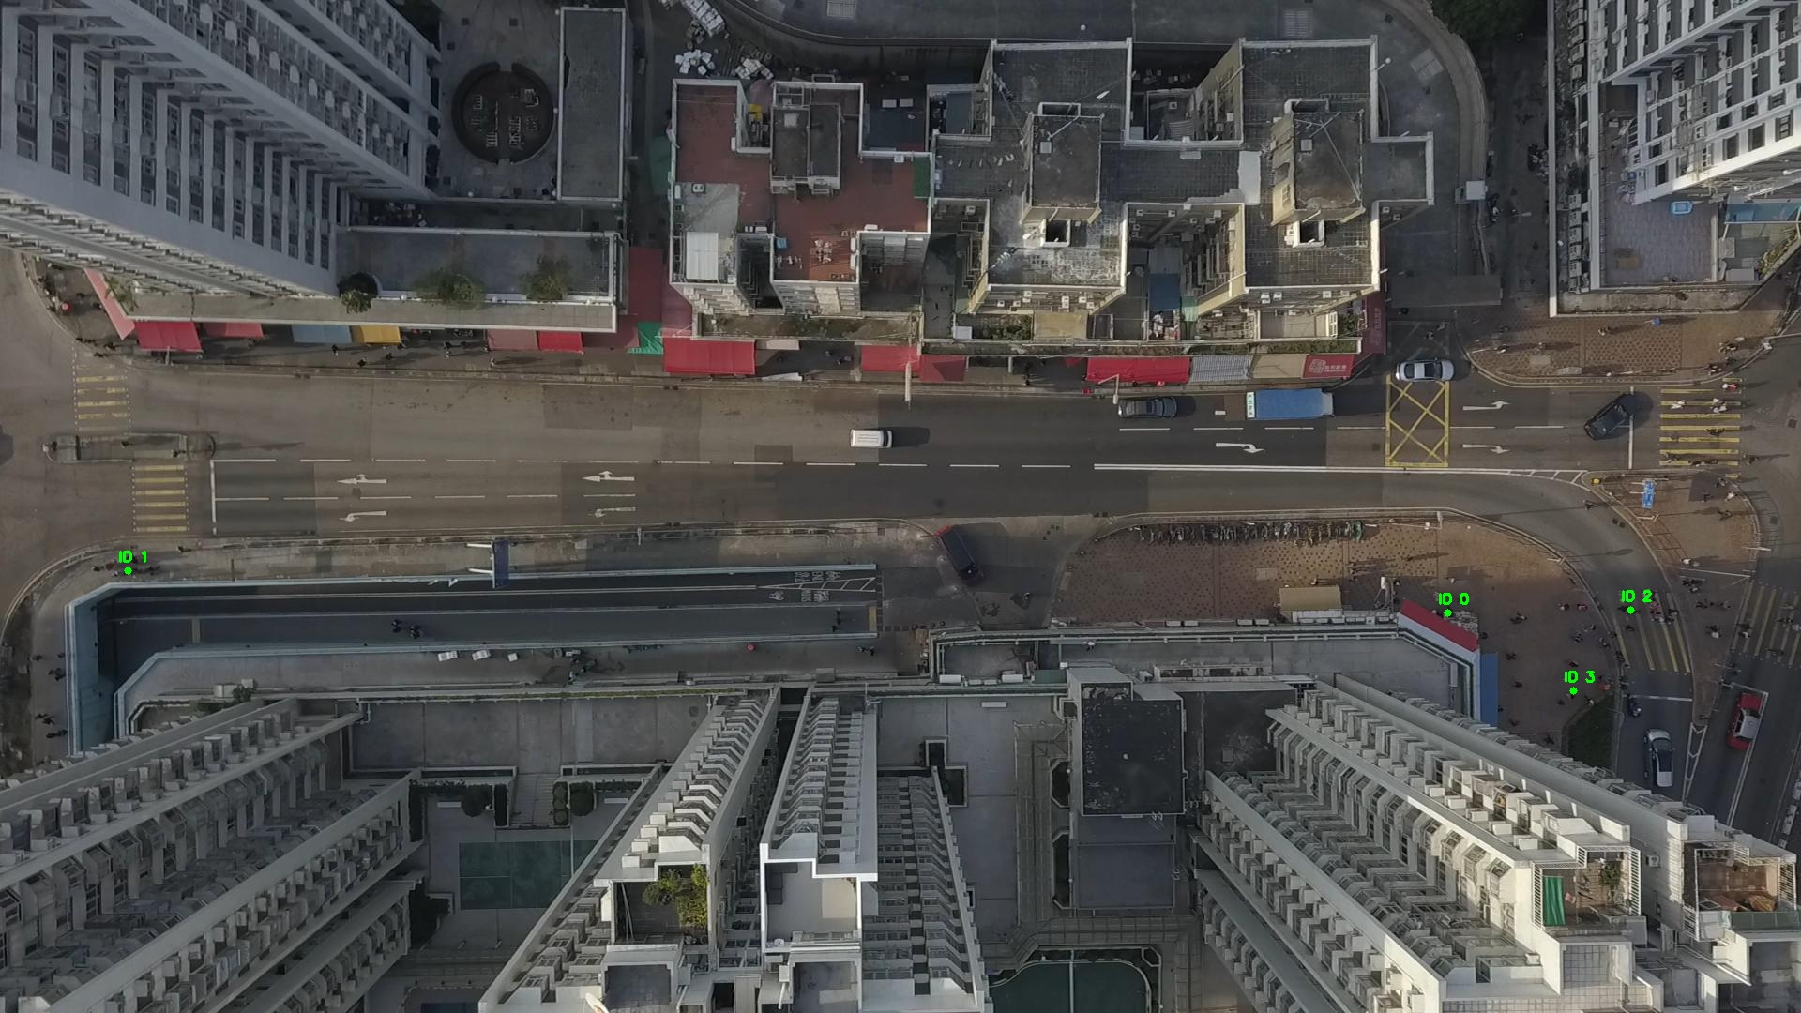

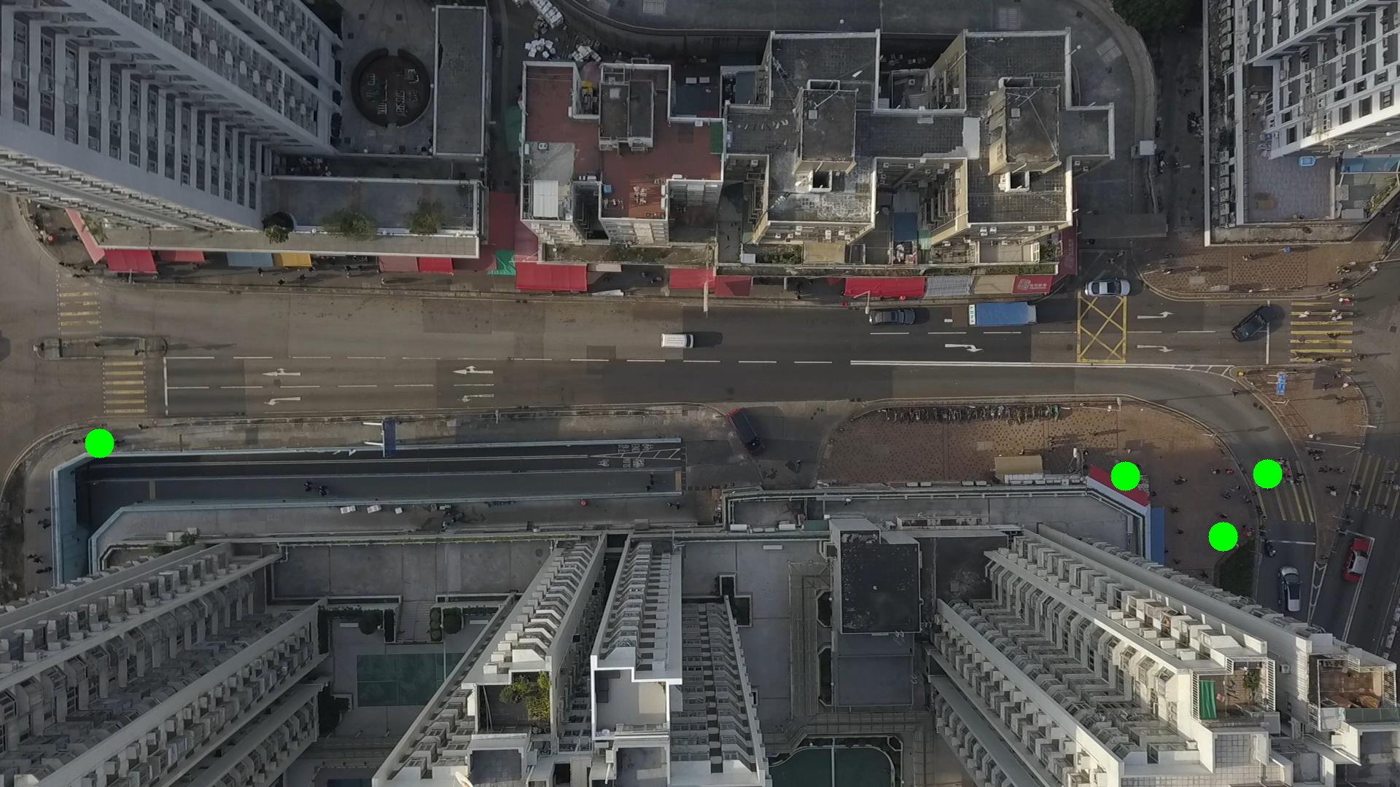

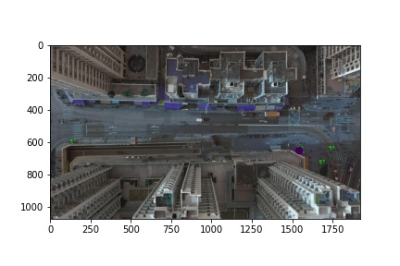

Silhouette metric for img015012.jpg is: 0.9974888761601414

Davies Bouldin metric for img015012.jpg is: 0.0029426629993581205

Calinski Harabasz metric for img015012.jpg is: 1758046.6463726778

ID 0: (1544, 652)

ID 1: (138, 609)

ID 2: (1738, 650)

ID 3: (1677, 736)

